26.39: a) The time constant
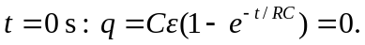
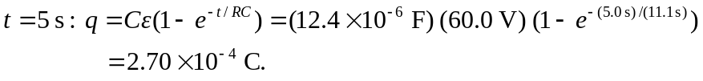
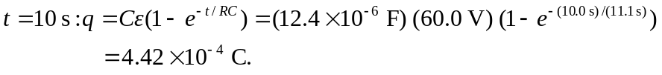
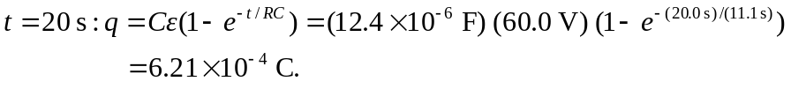
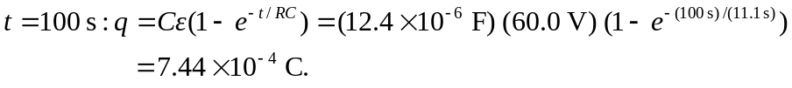
b) The current at time t is given by: 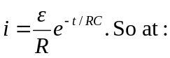
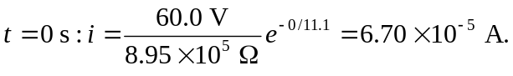
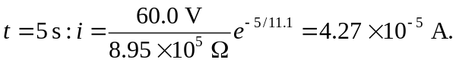
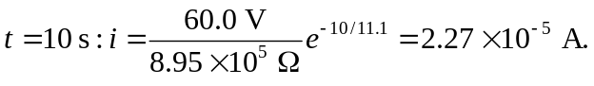
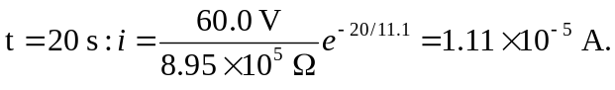
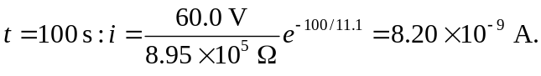
c) Charge against time:

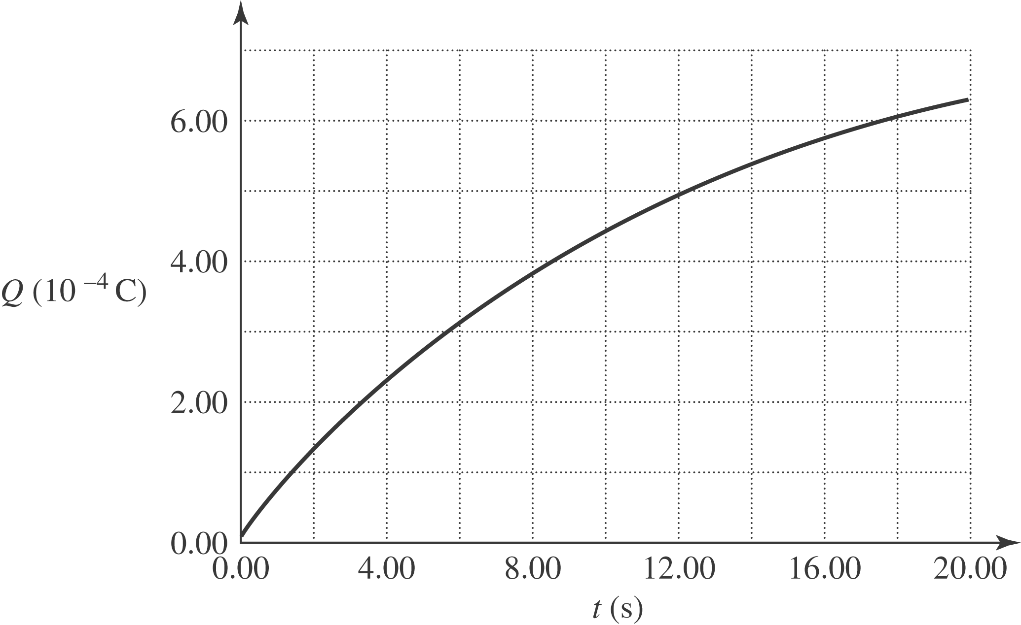

Current against time:

